**Date: 12/12/2019**

**Course**: Engineering INFO7250 Big Data Systems

**Name**: Pramod Nagare

**NUID**: 001858910

**Email**: [nagare.p@husky.ney.edu](mailto:nagare.p@husky.ney.edu)

**Project**: Streaming data pipeline for real-time analytics

**Highlights:**

* GCP Streaming and Batch Processing data analytical pipeline
* Bloom filter
* Hadoop cluster setup
* Google data explorer interactive dashboard
* Optimization (Combiner, distributed caches, cluster, compact data type)
* Multithread/multiprocessor scripts for data preparation

**Dataset:**

* https://registry.opendata.aws/amazon-reviews/
* https://github.com/awslabs/open-data-registry/blob/master/datasets/amazon-reviews.yaml
* https://s3.amazonaws.com/amazon-reviews-pds/readme.html
* 34+ GB Dataset .gzip format
* 130+ millions amazon customer reviews

**Task 1: Data download and extraction**

Implementation:

1. Downloading AWS Customer review data from source (AWS S3 bucket)

* Data Size: 130+ millions of rows, ~80GB of data over 51 files
* More details can be found on index.txt file
* Developed parallel processing python script

1. Extracting downloaded .gzip file into tsv

* Developed parallel processing python script

**Task 2: Building streaming data analytics pipeline**

Implementation:

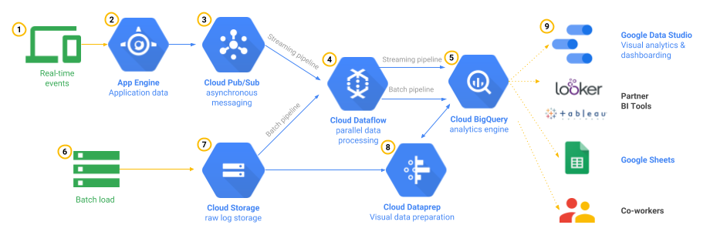

1. Architecture implementation:

* Created streaming data analytical pipeline using GCP pub/sub and python
* Developed a multi-process python script for data upload to GCP Big Query
* This script can take .tsv.gz as an input, we are saving time of extracting multiple files

1. Data querying using Big Query:

* Implemented simple queried to explore Big Query

**Task 3: Real Time data visualization**

Implementation:

1. Developed interactive dashboard using Google Data explorer

* Created custom fields for detail data analysis
* Data visualization using interactive graphs
* Export and shared the dashboard

**Task 4: Bloom filter**

Implementation:

1. Designed and developed bloom filter for stop word, positive and negative word analysis
2. Tried importing and exporting bloom filter using pickle file in python and data output stream in java

**Task 5: Map Reduce for Sentiment Analysis**

Implementation:

1. Created map-reduce jobs in python on Hadoop using Hadoop streaming jar
2. Tested map-reduce on local machine
3. Implemented both MR jobs with bloom filter and without bloom filter
4. Optimized the MR jobs with Hadoop best practices

* Using compact data type for the job
* Using combiner
* Running MR jobs on Hadoop cluster on GCP and AWS
* Implemented distributed caches

**Task 6: Hadoop Cluster setup on GCP**

Implementation:

1. Created a GCP Hadoop cluster with 2 worker nodes and 1 master
2. Submitted MR jobs on cluster using GCP utility
3. Implemented persistent storage for MR jobs
4. Ran some MR jobs on cluster with SSH to master node
5. Accessed the Hadoop dashboard for the job monitoring

**Task 7: Conclusion**

* **Parallel processes for file download are limited by internet speed**
* **Parallel processes for file extraction are limited by disk I/O**
* **MR Job Performance observation**

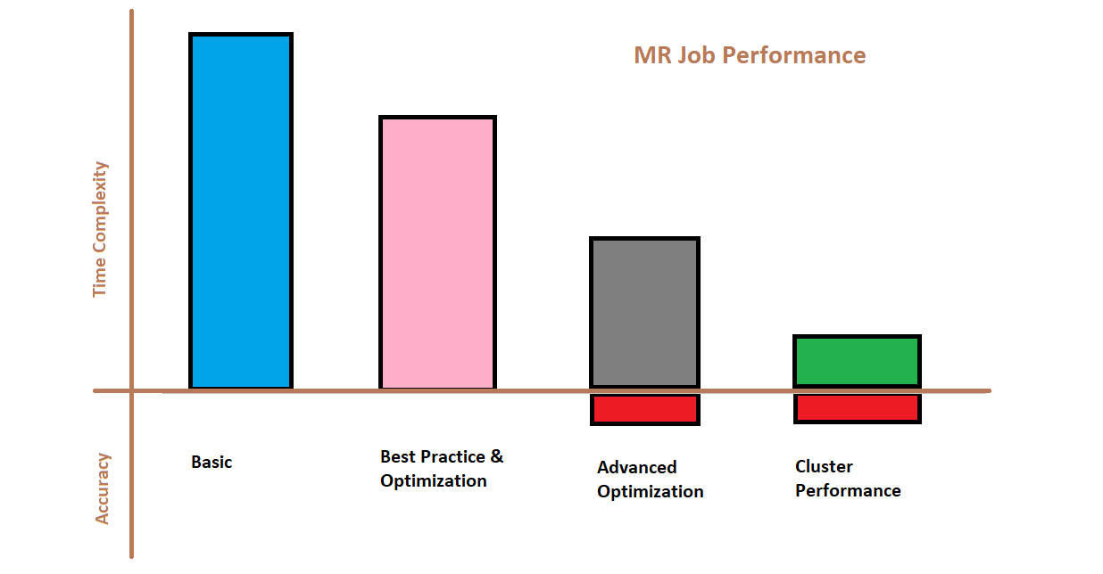

**Best Practices:**

1. Use compact / optimize data type in MR jobs
2. Use of combiners
3. Use file compressions format (ex. LZO)
4. Distributed caching
5. Multiple mapper and reducer

**Advanced Optimization:**

1. Bloom filter